Hello everyone, today I will be presenting a detailed analysis of consumer complaints related to the housing market. This analysis specifically focuses on mortgage-related complaints, loan modifications, collections, foreclosures, along with complaints involving real estate agencies and brokers. The study spans multiple years, aiming to identify significant trends, I focused on a hypothesis that there was a notable spike in these complaints during 2017.

The data for this analysis comes from a Consumer Complaints data set. Several steps were undertaken to prepare this data for meaningful insights:

1. The data was cleaned by removing quotes and replacing spaces with underscores.
2. The 'date received' column was converted to a date type, which was essential for time series analysis.

To address my initial hypothesis that mortgage-related complaints spiked in 2017:

1. I filtered the dataset to include only mortgage-related complaints.
2. The data was grouped by year to count the number of complaints each year.
3. A visualization was created to show the trend of mortgage-related complaints over time.

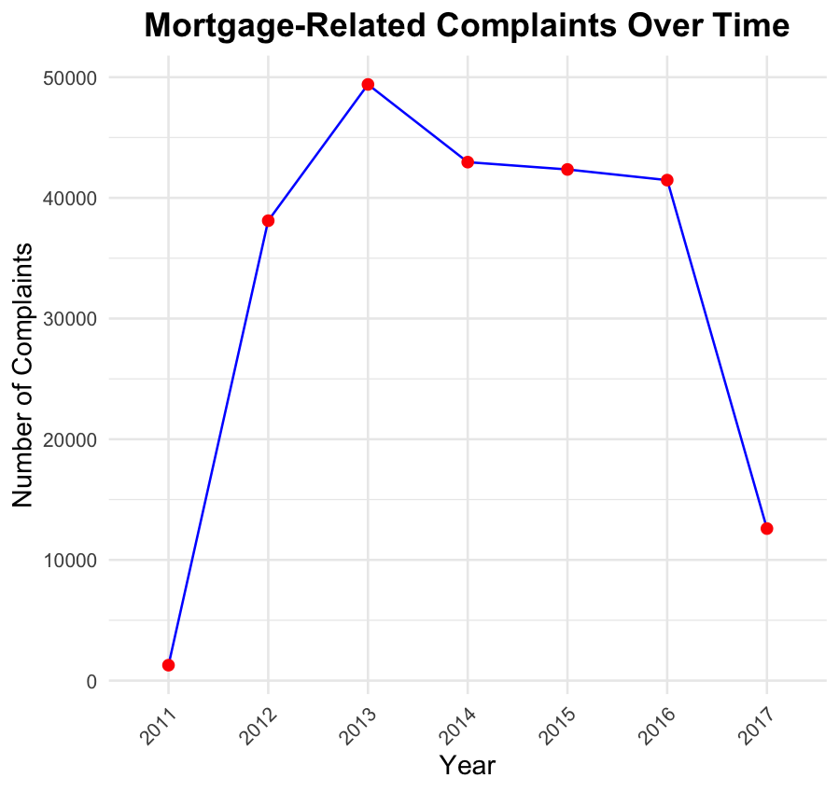

The resulting plot, however, did not show a significant spike in complaints during 2017 as hypothesized.

For the second hypothesis, I analyzed complaints related to loan modifications, collections, and foreclosures:

1. The data was filtered to include only these types of complaints.
2. Complaints were grouped by year to count the occurrences each year.
3. A line plot was created to visualize the trend over time.

The analysis did not reveal a spike in complaints related to loan modifications, collections, and foreclosures in 2017.

Finally, I examined complaints involving real estate agencies and brokers:

1. The dataset was filtered to include complaints related to real estate agencies and brokers.
2. The data was grouped by date to count the number of complaints.
3. A trend visualization was created to observe any significant patterns over time.

This graph did indicate a spike in complaints towards real estate agencies and brokers at the beginning of 2017.

In conclusion:

* The majority of consumer complaints were about mortgages, with the highest number occurring in 2013 rather than 2017.
* A significant portion of these complaints were directed at banks, specifically Bank of America and Wells Fargo.
* The volatility of the real estate market between 2013 and 2017 likely contributed to the high volume of complaints, mainly stemming from issues related to loan modifications, collections, and foreclosures.

Thank you for your attention. I am now open to any questions you may have regarding this analysis.

This graph represents the number of consumer complaints over time. As you can see, the data points are spread across multiple years, and while there are fluctuations, the significant spikes do not align with 2017 for mortgage-related complaints but do show an increase in early 2017 for complaints involving real estate agencies and brokers.

